Лабораторна робота 11

Візуальне програмування

Паршин Олександр

/\*

\*/

package Lab11;

/\*\*

\*

\* @author parsh

\*/

public class headpiece extends javax.swing.JFrame {

/\*\*

\* Creates new form headpiece

\*/

public headpiece() {

initComponents();

}

private void formKeyPressed(java.awt.event.KeyEvent evt) {

// TODO add your handling code here:

this.setVisible(false);

lab11.Visible1(true);

}

private void formMouseClicked(java.awt.event.MouseEvent evt) {

// TODO add your handling code here:

this.setVisible(false);

lab11.Visible1(true);

}

/\*\*

\* @param args the command line arguments

\*/

public static void main(String args[]) {

/\* Create and display the form \*/

java.awt.EventQueue.invokeLater(new Runnable() {

public void run() {

new headpiece().setVisible(true);

}

});

}

// Variables declaration - do not modify

private javax.swing.JLabel jLabel1;

private javax.swing.JLabel jLabel2;

private javax.swing.JLabel jLabel3;

private javax.swing.JLabel jLabel4;

// End of variables declaration

}

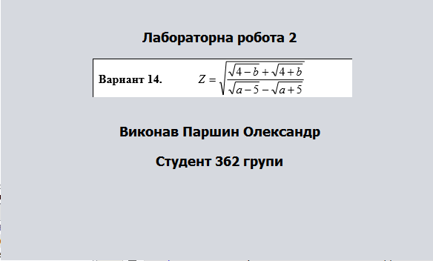

/\*

\*/

package Lab11;

import javax.swing.JOptionPane;

/\*\*

\*

\* @author parsh

\*/

public class lab11 extends javax.swing.JFrame {

/\*\*

\* Creates new form lab11

\*/

public lab11() {

initComponents();

}

private void jButton1ActionPerformed(java.awt.event.ActionEvent evt) {

// TODO add your handling code here:

double a;

double b;

String Z = "Что то не то";

try

{

a = Double.parseDouble(jTextField1.getText());

b = Double.parseDouble(jTextField2.getText());

double z = Math.sqrt((Math.sqrt(4-b) + Math.sqrt(4+b)) / ((Math.sqrt(a-5) - Math.sqrt(a+5))) );

Z = String.valueOf(z);

}catch(Exception e)

{

JOptionPane.showMessageDialog(null, "Ошибка входных данных");

}

jLabel3.setText(Z);

}

private void jTextField1ActionPerformed(java.awt.event.ActionEvent evt) {

// TODO add your handling code here:

}

private void jTextField2ActionPerformed(java.awt.event.ActionEvent evt) {

// TODO add your handling code here:

}

/\*\*

\* @param args the command line arguments

\*/

public static void main(String args[]) {

/\* Create and display the form \*/

java.awt.EventQueue.invokeLater(new Runnable() {

public void run() {

new lab11().setVisible(false);

}

});

}

public static void Visible1(boolean a)

{

new lab11().setVisible(a);

}

// Variables declaration - do not modify

private javax.swing.JButton jButton1;

private javax.swing.JLabel jLabel1;

private javax.swing.JLabel jLabel2;

private javax.swing.JLabel jLabel3;

private javax.swing.JLabel jLabel4;

private javax.swing.JTextField jTextField1;

private javax.swing.JTextField jTextField2;

// End of variables declaration

}

